

Annex 1

XIII ITALIAN INTERNATIONAL

ACCOMMODATION FORM

to be returned to

Hotel: | Belvedere | send to: | commerciale@hotelbelvedereostia.com
Hotel: | Federal Sport Center FIN | send to: | cfostia@federnuoto.it
Hotel: | Federal Sport Center Palafijlkam | send to: | caudullo.mariaelisabetta@fijlkam.it centro.olimpico@fijlkam.it

and copy to patriziagaleani@badmintonitalia.it not later than November 20th

National Association

Phone and Fax number

Contact person

Credit Card Number

E-mail-address

Nr. | Last Name | First Name | Single Double  Triple | Sharing with: | CHECK IN | CHECK OUT
1
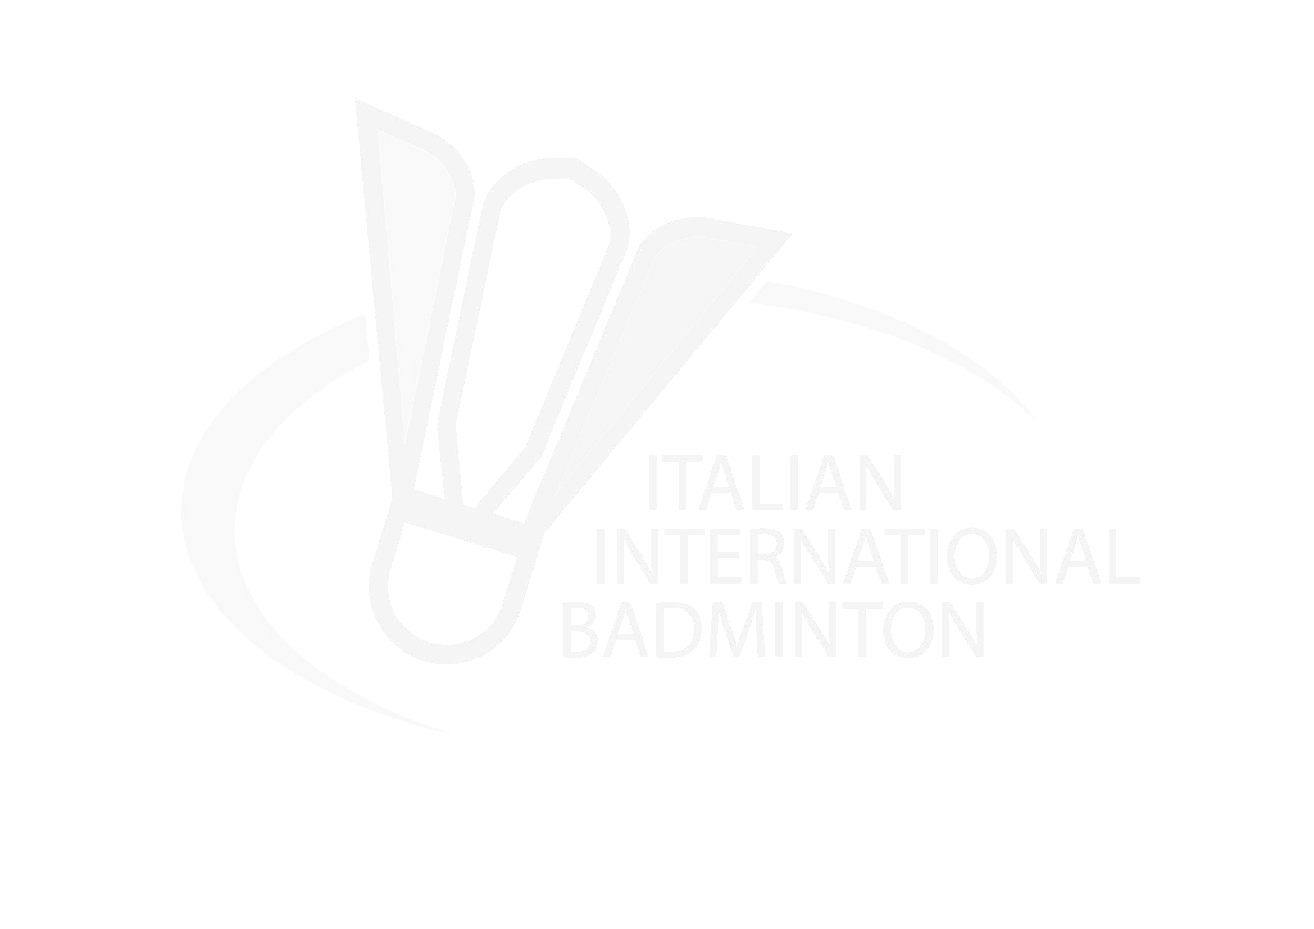
2
3
4
5
6
7
8
9
10
11
12
13
14
15

Annex 2.1

XIII ITALIAN INTERNATIONAL

TRAVEL FORM
TO and FROM FIUMICINO AIRPORT
the transfer service is free of charge
MEETING POINT: TERMINAL 3

to be returned to elianapassaniti@badmintonitalia.it – patriziagaleani@badmintonitalia.it

not later than November 20th

National Association

Phone and Fax number

Contact person

E-mail-address

Arrival details TO FIUMICINO AIRPORT
Arrival Date
Arrival Time
Flight Number
Terminal number
Airline Company
Number seats for reservation | N°

Departure details FROM FIUMICINO AIRPORT
Departure Date
Departure Time
Flight Number
Terminal number
Airline Company
Number seats for reservation | N°

Annex 2.2

XIII ITALIAN INTERNATIONAL

TRAVEL FORM
TO and FROM CIAMPINO AIRPORT
the transfer service is subject to charges (12 euro/trip/pax) – for group minimum 3 pax

to be returned to elianapassaniti@badmintonitalia.it - patriziagaleani@badmintonitalia.it

not later than November 20th

National Association

Phone and Fax number

Contact person

E-mail-address

Arrival details TO CIAMPINO AIRPORT
Arrival Date
Arrival Time
Flight Number
Terminal number
Airline Company
Number and Names of people for reservation of seats in pick up | N°:  Names:

Departure details FROM CIAMPINO AIRPORT
Departure Date
Departure Time
Flight number
Terminal number
Airline Company
Number and Names of people for reservation seats in pick up | N°:  Names:

