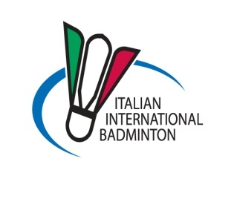Annex 1.1

20XV YONEX ITALIAN INTERNATIONAL
PalaBadminton, Milan 8-11 December 2015

TRAVEL FORM
MEETING POINT: Subway station QT8– exit Piazza Santa Maria Nascente.

to be returned to jenniferpizzuti@badmintonitalia.it

not later than November 20.

National Association

Phone and Fax number

Contact person

E-mail-address

Arrival details TO LINATE AIRPORT
Arrival Date
Arrival Time
Flight Number
Terminal number
Airline Company
Number seats for reservation | N°

Departure details FROM LINATE AIRPORT
Departure Date
Departure Time
Flight Number
Terminal number
Airline Company
Number seats for reservation | N°

